No change has been detected

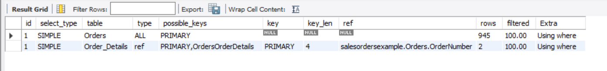

So creating the database and repeating this part (this time I named it as saleorderexample2 and thus will follow that name for the rest of this excercise)

But still no change was observed

(for the 945 became 944 part, its because now there is no extra row which had been added to the table in week9)

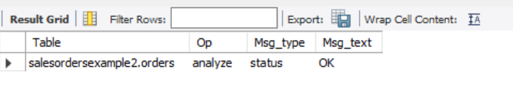

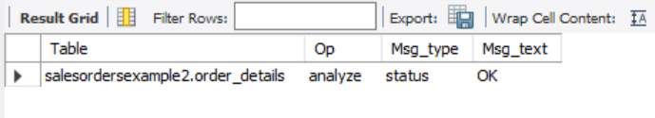

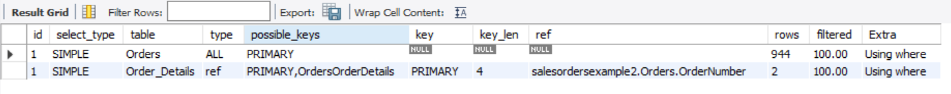

ANALYZE TABLE performs a key distribution analysis and stores the distribution for the named table or tables (index statistics). This stored key distribution is then used to decide the order in which tables should be joined when “join”command is used. Also it is used to decide which indexes to be used for a speficic table within a query. Thus it can be used to determine the most efficient execution plan for the query

(Reference: <https://mariadb.com/kb/en/analyze-table/> and google and tutorial video)